**CIND 719 – Assignment 1**

Brendan Dagys

6)

hadoop fs -put /root/lab/u.data /user/lab

hadoop fs -put /root/lab/u.item /user/lab

7)

create table ratings (user_id int, movie_id int, rating int, unixtime bigint) row format delimited fields terminated by '\t';

load data inpath '/user/lab/u.data' into table ratings;

create table movies (movie_id int, movie_title string, release_date string, v_release_date string, imdb_url string, cat_unknown int, cat_action int, cat_adventure int, cat_animation int, cat_children int, cat_comedy int, cat_crime int, cat_documentary int, cat_drama int, cat_fantasy int, cat_film_noir int, cat_horror int, cat_musical int, cat_mystery int, cat_romance int, cat_scifi int, cat_thriller int, cat_war int, cat_western int) row format delimited fields terminated by '|';

load data inpath '/user/lab/u.item' into table movies;

**QUESTIONS**

**1)**

select count(*) from ratings;

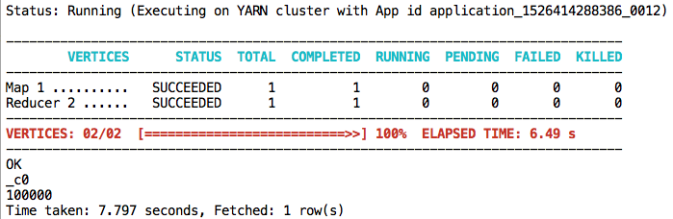

select count(*) from movies;

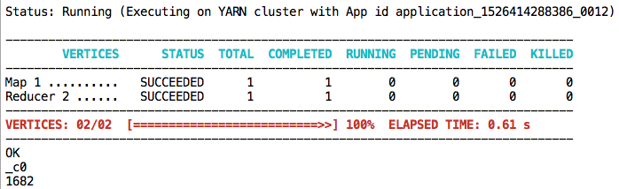

**2)**

select movie_title from movies where release_date REGEXP '1990';

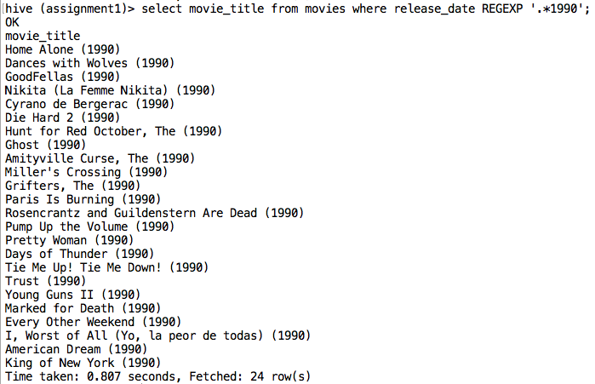

**3)**

select movie_id, count(rating) cnt from ratings group by movie_id order by cnt desc limit 10;

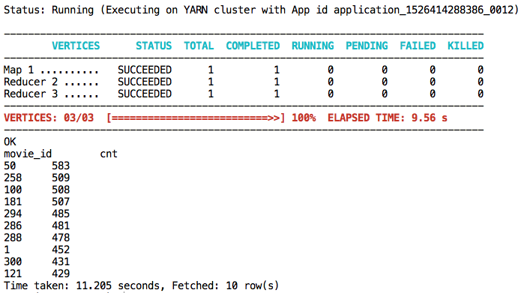

**4)**

select movie_title, count(rating) cnt from (movies m join ratings r on m.movie_id = r.movie_id) group by movie_title order by cnt desc limit 10;

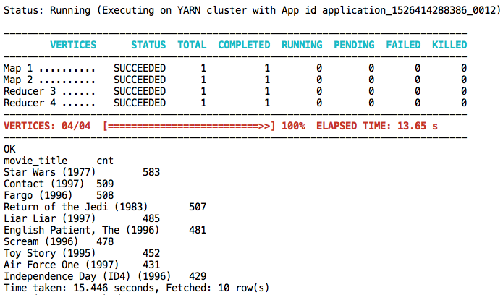

**5)**

select movie_title, avg(rating) score from (movies m join ratings r on m.movie_id = r.movie_id) where cat_scifi = 1 group by movie_title order by score desc limit 1;

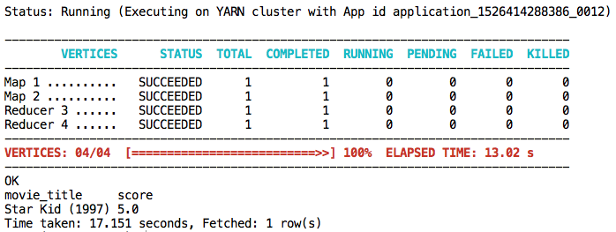

The highest-rated movie will be the movie with the highest average score (rating column) amongst all reviewers that reviewed that movie.

**BONUS)**

select * from (movies full outer join ratings) where rating IS NULL;

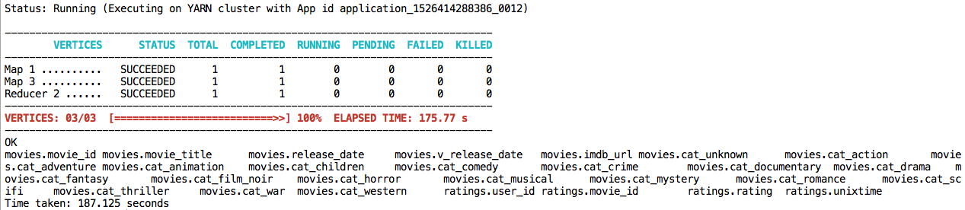

There are no movies without a rating. They all have a rating.